Exercise 1 – Targeting Your Church’s Hybrid Presence
Using the X-Y graph below, consider the following:
- (x-axis) Examine the descriptors which are top-most on the left. Using the “Exercise 1 Chart – Resources and Technology” for each member of your team, discuss each of these descriptors with and have each member give each a ranking from 1-10 where 10 represents that this descriptor has been fully realized and where 1 represents that your church is only beginning to work on this bullet.
- Average your scores and based on a score of 1-10, locate where your church sits vertically on this graph -- where 1 is at the bottom of this graph and 10, at the top.
- (y-axis) Examine the descriptors which are bottom-most and on the right. Discuss each of these descriptors with your team members and give each a ranking from 1-10 where 10 represents that this descriptor has been fully realized and where 1 represents that your church is only beginning to work on this bullet. Average your scores and based on a score of 1-10, locate where your church sits horizontally on this graph.
- Move the point identified in bullet 1 to the right such that it is now located in line with both your x-axis and y-axis score.
- Move to Exercise 2.
10
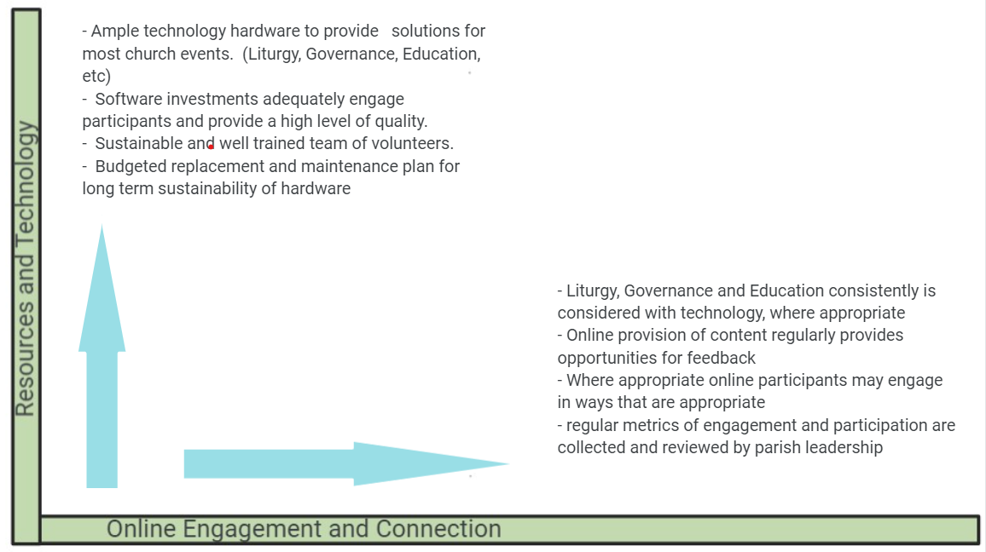
10
5
1
5

Exercise 1 Chart – Resources and Technology
Using the chart below, consider each descriptor and then discuss with your group. Individually rank where you believe your church is with respect to this descriptor. (1 is the lowest ranking and 10 is the highest).
Criteria To Consider | 1-10
Our church has ample hardware available to provide solutions for most church events. (liturgy, governance, education, etc.)
Our software investments adequately engage participants and provide a high level of quality.
Our AV team has a sustainable and well-trained number of volunteers
We have budget for long term sustainability of our hardware.
Average Score

Online Connection and Engagement
Using the chart below, consider each descriptor and then discuss with your group. Individually rank where you believe your church is with respect to this descriptor. (1 is the lowest ranking and 10 is the highest).
Criteria To Consider | 1-10
Liturgy, Governance and Education is consistently considered with technology in mind, where appropriate
Online provision of content regularly provides opportunities for feedback
Where appropriate, online participants may participate
Regular metrics of online engagement and participation are collected and reviewed by parish leadership
Average Score

Exercise 2 – Understanding Your Parish Hybrid Presence & Forward Planning
After locating your parish on the X – Y Graph from Exercise 1, transfer the location to this graph and consider whether the description matches your church’s current context.

Discussion and Forward Planning
Given where your church is located in this 2 X 2, discuss the following prompts with your planning team:
- Do you agree with the broad description on this graph of your Hybrid presence?
- As the target quadrant for a well balanced Healthy and Effective Hybrid environment is Quadrant #2, are you far enough along from left to right or from bottom to top, to meet your congregation’s goals for online worship and engagement? Which direction should your church move?
- Given the descriptors at the top and right of the X-Y Graph in Exercise #1, what strategies make the most sense for your parish in order to move you to your desired location towards Quadrant #2 on this page?
Aspirational
Limited technical equipment, unsustainable number of volunteers and/or little long-term technical planning with limited engagement and online participation.
Engaged, connected online presence is busy in a variety of areas but may be challenged by technical issues, long-time volunteer & financial sustainability or with limited technical tools.
Aspirational & Engaged
HEALTHY AND EFFECTIVE HYBRID
Aspirational, sophisticated, sustainable, capable, engaged, busy and connected participants.

4
3
2
1
Sophisticated, capable, sustainable, well equipped and with online audience, but who may not report being fully engaged within the community in a variety of activities.
Resources and Technology
Online Engagement and Connection
Aspirational, Invested & Engaged
Aspirational & Investing

