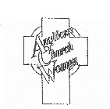
THE ANGLICAN CHURCH WOMEN
DIOCESE OF TORONTO

invite you to the

Annual General Meeting (Zoom)

SATURDAY APRIL 17, 2021
10:00 am – 12:00 noon

Theme
“Challenged to Move Forward”

Special Guest: The Most Reverend Linda Nicholls

The invitation with the registration link will be emailed to each church by March 19, 2021
also registration information will be on the Diocesan website March 22, 2021

For further information:
Telephone: 416-363-0018 (leave message) E-Mail: acw@toronto.anglican.ca
Diocesan website: toronto.anglican.ca

