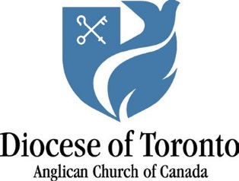
The Right Reverend Jenny Andison
Area Bishop of York-Credit Valley

The Incorporated Synod
of the Diocese of Toronto
135 Adelaide Street E. Toronto, ON M5C 1L8
Telephone: 416-363-6021
Toll-free: 1-800-668-8932
Fax: 416-363-7678 www.toronto.anglican.ca

A Pastoral Letter to Vestry 2021

January 6, 2021
The Feast of the Epiphany

But the Lord will be your everlasting light, your God will be your splendor. Isaiah 60:19

My sisters and brothers in Christ,

I am writing this on the great Feast of the Epiphany, when we remember and rejoice in the fact that the wise men worshipped the young Jesus as the Light of the World. As the first non-Jews to realize who Jesus is, the wise men boldly proclaim that the gospel is for all nations and all peoples, and that Jesus doesn’t just make local claims relevant only to the children of Israel, but global claims on the lives of all people, from Mississauga to Mauritius. What wonderfully good news: God sent his son to all the peoples of the world, not just a select few. In the York-Credit Valley Area, that good news is marvellously lived out in the global diversity found in our pews (and now online!).

Our interconnectedness as a global family has been brutally highlighted in 2020 as we battled with the devastation of the COVID-19 pandemic. And while you don’t need me to tell you about the painful and deadly impact that this virus has had on the world, our city, our churches and our own lives, I do want to encourage you with how Anglicans across our Diocese have risen to the challenges now set before us. I have heard of and seen the creative online offerings of worship, Messy Church and Alpha on Zoom, meals and food still being provided to the homeless, more phone calls to the lonely and isolated, and money raised for FaithWorks. Through it all, it has been a joy to see how you have all partnered with the Holy Spirit during the twists and turns of this past year.

On the occasion of your Annual Vestry Meeting, I particularly want to thank all of you who serve in formal leadership roles in your parishes (as Wardens and Treasurers) and of course, your parish clergy, too. When you were recruited for your role, I am pretty sure that it was not mentioned that a global pandemic was on the way! Finances are being significantly stretched, workload seems to have doubled, and some parishes are now unsure of what their future holds. In the midst of this anxiety and exhaustion, your service to Christ still ascends to our Heavenly Father as a fragrant offering. Thank you so very much.

I also commend to your prayerful care our Diocesan Social Justice Vestry Motion. This important motion acknowledges that anti-Black racism is a sinful reality in our lives, our society and in our churches and pledges us, through the grace of God, to work towards the dismantling of all forms of personal and institutional racism.

This is my last letter to you as your Area Bishop. I was consecrated as a bishop four years ago on the Feast of the Epiphany, and it has been a singular privilege to serve in York-Credit Valley, taking with
me a treasure trove of wonderful experiences of watching the living God move and be active in your lives and in your parishes. While it has come as a surprise, to both you and to me, that God has called me to St. Paul, Bloor Street, I am grateful to be continuing my episcopal ministry in gospel partnership with all of you.

I would urge you during this coming year, as the pandemic continues to unfold and the York-Credit Valley Area goes through a season of transition, to cling to the Lord Jesus Christ, be steadfast in prayer, and to persevere in seeking ways to reach out evangelistically, both online and in person, to all those who are spiritually hungry in our neighbourhoods.

Please know that I will continue to hold you all in prayer this coming year. This year offers both deep challenges and the promise that the God who reveals Godself in the life, death and resurrection of Jesus, will never leave us or forsake us.

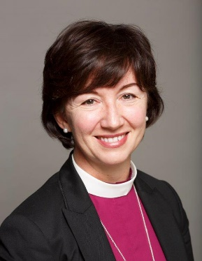
Peace,
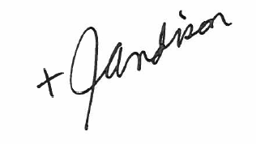
The Right Reverend Jennifer Andison
Area Bishop of York-Credit Valley
Bishop Suffragan of Toronto

