**Recommendations for improving ventilation and air cleaning:**

Be flexible in your approach to meeting changing public health guidelines as we struggle with the fourth wave in Canada.

Assemble an interdisciplinary team including an HVAC professional to review the ventilation configuration for your church and proposed occupancy uses.

Develop feasible options for control of infectious aerosols with scope, budgets and schedules.

**The role of ventilation and air filtering:**

No single intervention can prevent the spread of COVID-19. We know that vaccines are our best defense but they are not perfect. Defense against the spreading of respiratory virus has been likened to adding layers of swiss cheese. The more layers that are added, the more difficult it is for the virus to penetrate. Some of the “slices of cheese” are within an individual’s control and others fall into the category of shared responsibilities. By improving the ventilation in our church buildings, we can add an important layer of protection against the spread of COVID-19.

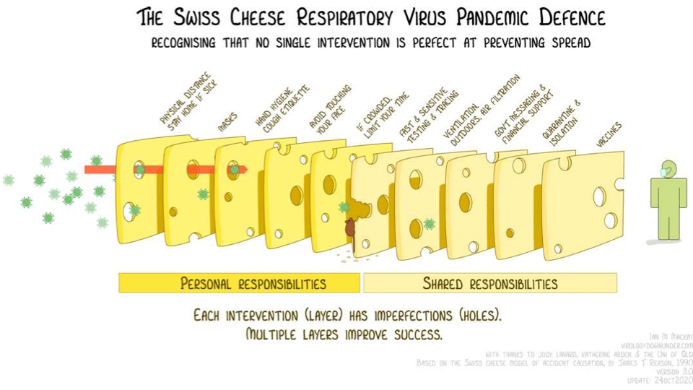

Heating, ventilation, air conditioning (HVAC) is an important tool in our toolkit to supply clean air using filters, air cleaners and other removal systems. These systems are complex, require regular maintenance, and there is no one size fits all. The goal is to supply clean air to the occupied space and remove infectious aerosol from the breathing space of occupants. There isn’t an off the shelf way to approach this. Parishes will need to work with HVAC specialists who will develop guidance for system operations to achieve flexible exposure reduction goals to meet changing health guidelines but also recognize constraints of comfort, energy and costs. For some of our buildings, such as the Cathedral, adding an HVAC system is very difficult. Given the space, it would be cost prohibitive. That does not mean that there is nothing that can be done to improve ventilation in the Cathedral, and it also means that individuals attending the Cathedral will be relying more heavily on the other slices of cheese.

**Resources:**

The American Society of Heating and Air-Conditioning Engineers (ASHRAE) hs published guidelines for the control of airborne infectious aerosol exposures and recommendations for communities of faith building. These are excellent guidelines that offer a clear approach to reducing the risk of infectious exposure for building occupants.

[https://www.ashrae.org/about/news/2021/ashrae-epidemic-task-force-releases-core-recommendations-for-reducing-airborne-infectious-aerosol-exposure-and-communities-of-faith-building-guidance](https://linkprotect.cudasvc.com/url?a=https%3a%2f%2fwww.ashrae.org%2fabout%2fnews%2f2021%2fashrae-epidemic-task-force-releases-core-recommendations-for-reducing-airborne-infectious-aerosol-exposure-and-communities-of-faith-building-guidance&c=E,1,HNJeERUY6O_IcuyTv-wvdtgxvKoONIcNRgViOCHwvqOvwtnxJLwxsV4pXlY3tzS4aX9rVClJ6pir5gakz-c2RJOe8NrEKvLOd4ah1NK5I88qmXmvMhQ8_Q,,&typo=1)