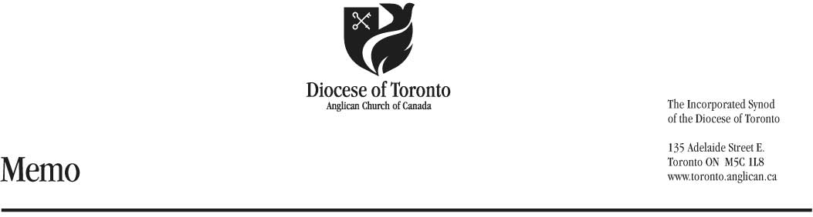

Date: August 11, 2021

To: All Active Clergy of the Diocese of Toronto

From: Keri Stilling
General Accountant

Subject: CRA Form T1213

This is a reminder that this is the time of the year to file your form T1213 for 2022. Clergy who are receiving a housing allowance must file Form T1213 and receive prior written approval from the CRA before being allowed a reduction of tax at source. If you are living in a rectory you do not need to file a T1213. It is your (the employee’s) responsibility to file Form T1213.

The following steps are to be taken:
- Complete, sign and date the T1213.
- Fill in the identification section
- Under “Request to reduce tax on”, check salary
- At the top of page 2 next to Clergy Residence, write in the housing deduction amount as calculated on your T1223. The line “Net amount requested for tax waiver” should have the same amount, unless you are also seeking additional amounts on the T1213 form.
- Attach the EMPLOYER letter from the Diocese included in this package. If you are receiving a housing allowance and a letter is not enclosed, please call Keri Stilling at (416) 363-6021 x 239 or
1 (800) 668-8932 x 239 and a copy will be sent to you.
- A copy of your T1223 (Clergy Residence Deduction) for the year 2022 is also attached together with your Job Description which you have to fill out. CRA is also asking for proof of appointment (i.e. an ordination certificate) to be submitted.
- Some clergy were asked for a Fair Market Value (with utilities) assessment letter from a real estate agent in prior years. Please consider getting one and submitting it with your application package.
- Submit to the London Tax Services Office, 451 Talbot Street, London ON N6A 5E5 no later than September 30, 2021 to ensure approval is received by the January 2022 payroll cut-off, as we are being advised it takes up to 16 weeks to process by the CRA.

Please note that your written approval from the CRA must be received by the Diocesan payroll office by January 14, 2022, otherwise, your housing allowance will be treated as a taxable benefit, until such time as we receive CRA approval, which will result in reduction of take-home (net) pay. No exceptions can be made.

Once you receive a copy of your CRA approval, please send a copy to the Finance Department by:
- Mail: Anglican Diocese of Toronto
c/o Keri Stilling, General Accountant
135 Adelaide St. E.,
Toronto, ON M5C 1L8
- Fax: (416) 363-7678 or
- Email: kstilling@toronto.anglican.ca

