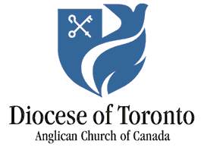

Prayer Cycle for December 2021
- Philip Aziz HIV/AIDS Hospice – a FaithWorks ministry
- All Saints, Peterborough
- St. George, Hastings
- The Chapel of Christ Church, Lakefield
- Project Ploughshares – the peace institute of the Canadian Council of Churches
- FaithWorks shelters for women and children at risk
- Christ Church, Campbellford
- Christ Church, Norwood
- St. George-the-Martyr, Apsley
- Bishop Kevin Robertson, Diversity Officer for the Diocese
- St. James, Emily
- Peterborough Deanery
- St. James, Roseneath
- St. John the Baptist, Lakefield
- St. John the Evangelist, Havelock
- St. John the Evangelist, Peterborough
- St. John, Ida
- Christian-Jewish Dialogue of Toronto (CJDT)
- The Anglican Church Women (ACW) – Enid Corbett, diocesan president
- St. Matthew and St. Aidan, Buckhorn
- St. Michael, Westwood
- St. Peter on-the-Rock, Stony Lake
- St. Stephen, Chandos
- Christ Church, Omemee
- Christmas Day
- Black Anglicans of Canada and the International Decade for People of African Descent
- St. Thomas, Millbrook
- St. Luke, Peterborough
- The staff of the Synod Office
- Chaplains to the Retired Clergy
- Founders and Benefactors of the Diocese of Toronto

