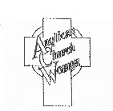
THE ANGLICAN CHURCH WOMEN
DIOCESE OF TORONTO

invite you to the

Annual General Meeting (Zoom)

SATURDAY APRIL 30, 2022
10:00 am – 12:00 noon

Theme
“Renewed For Change”

Special Guest: Scott Brubacher
Anglican Foundation of Canada
“Say Yes to Kids”

The invitation with the registration link will be emailed to each church by April 1, 2022
also registration information will be on the Diocesan website April 1, 2022

For further information:
Telephone: 416-363-0018 (leave message) e-mail: acw@toronto.anglican.ca
Diocesan website: toronto.anglican.ca

