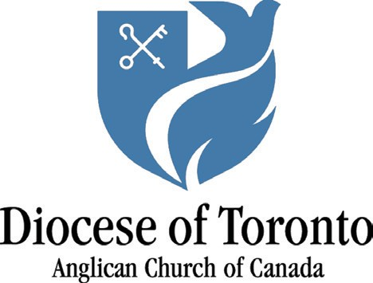The Incorporated Synod of the Diocese of Toronto
135 Adelaide Street E. Toronto, ON M5C 1L8
Telephone: 416-363-6021
Toll-free: 1-800-668-8932
Fax: 416-363-7678 www.toronto.anglican.ca

The Rt. Honourable Justin Trudeau, Prime Minister of Canada,
The Honourable Chrystia Freeland, Deputy Prime Minister and Minister of Finance,
The Honourable Kamal Khera, Minister of Diversity, Inclusion, and Persons with Disabilities

March 8, 2024

BY EMAIL

Dear Prime Minister Trudeau, Minister Freeland, and Minister Khera,

We are writing to urge your government to fully fund the Canada Disability Benefit in the upcoming federal budget.
People with disabilities make up a disproportionate number of Canadians living in poverty, being twice as likely to live in poverty as Canadians without disabilities. Across Canada, nearly one million working-age people with disabilities live in poverty.
In the City of Toronto, 35% of food bank clients – more than one third - are living with a disability. The maximum amount a single Ontarian with disabilities can receive on the Ontario Disability Support Program is just over $1,300 per month, more than $1000 below the poverty line. People with disabilities are regularly forced to make impossible choices between their basic necessities of food, rent, transportation and medications, as their income supports are too meagre to cover their needs. Anglican parishes in our Diocese see the impacts of disability poverty every day among those who come to our food banks, community meal programs, and approach us for material assistance. The need is growing.
We were pleased to see the Canada Disability Benefit Act passed unanimously in June of 2023. We appreciate that it takes time to design the benefit. But people with disabilities can’t afford to wait. This benefit needs to be rolled out swiftly to lift Canadians with disabilities out of poverty.
We urge you to commit to fully funding the Canada Disability Benefit in the 2024 federal budget. Together with the Daily Bread Food Bank and other advocacy organizations, we call on you to ensure that the benefit:
- Is fully-funded to lift people with disabilities out of poverty
- Is barrier-free and inclusive of people with all types of disabilities
- Must supplement existing income support programs and be safe from clawbacks.
The time to act is now. Please make the Canada Disability Benefit a reality for those who need it by funding it in this year’s budget.

Yours faithfully,

Elin Goulden, Social Justice & Advocacy Consultant, Diocese of Toronto
The Rev. Canon Maggie Helwig, Chair, Social Justice & Advocacy Committee, Diocese of Toronto
The Rev. Canon Andrea Budgey, Chair, Poverty Reduction Subcommittee, Diocese of Toronto

