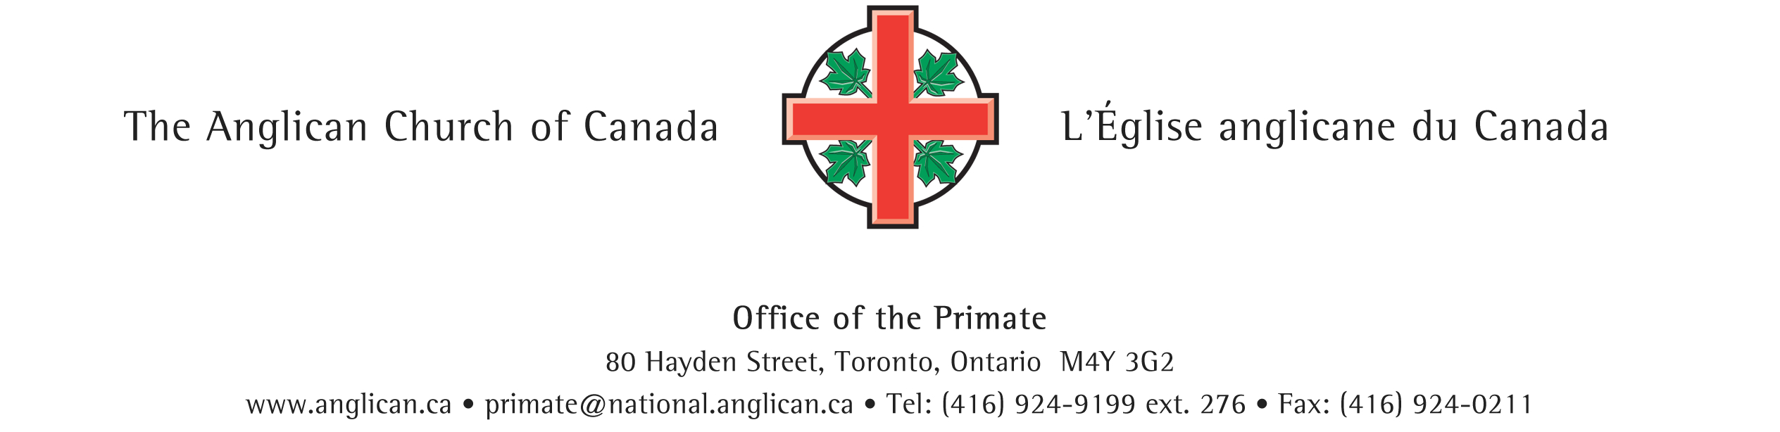

April 3, 2024

Dear Friends in Christ,

Warm greetings of the Easter season!

This year, World Refugee Day will be marked on June 20th; a time when we remember the over 110 million refugees and internally displaced people in the world and honour the work of those who “welcome the stranger.” I am therefore writing to invite you, your dioceses and parishes to consider celebrating a Refugee Sunday at some point in the month leading up to that day, or at another time this year.

As you are aware, 15 of our 30 dioceses are Sponsorship Agreement Holders (SAHs) with Immigration Refugees and Citizenship Canada (IRCC), enabling them to privately sponsor refugees to come to Canada. The proposal for a national Refugee Sunday emerged from a meeting of the PWRDF Refugee Network (Anglican SAHs) last fall and was presented at an online Refugee Sponsorship consultation in late January that I chaired on behalf of the Primate’s World Relief and Development Fund (PWRDF). PWRDF acts as the secretariat for the Network.

The Refugee Network is currently developing a modest set of information and prayer/worship resources that will be available on the PWRDF website and sent to all dioceses and to the Refugee Coordinators in those dioceses that are SAHs in early May. These resources will lift up the work of refugee sponsorship here in Canada, as well as the support offered to refugees overseas that has been a central part of PWRDF’s mandate since its inception in 1959; the year the United Nations declared to be World Refugee Year.

Should you have any questions about this invitation, please be welcome to contact Suzanne Rumsey, Public Engagement Program Coordinator at PWRDF: [srumsey@pwrdf.org](mailto:srumsey@pwrdf.org)

In gratitude for all the ways in which our church welcomes the stranger,



The Most Rev. Linda Nicholls

Archbishop & Primate