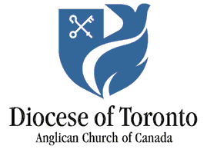

Prayer Cycle for December 2025
- Philip Aziz Centre – a FaithWorks ministry
- Bishop Mauricio Andrade, Diocese of Brasilia
- St. Aidan, Toronto
- St. Barnabas, Chester
- Resurrection
- FaithWorks shelters for women and children at risk
- Toronto East Deanery
- St. Bede
- St. David, Donlands and St. Andrew, Japanese
- St. John the Baptist, Norway
- St. Luke, East York
- St. Matthew, First Avenue
- St. Monica
- Tecumseth Deanery
- St. Nicholas, Birch Cliff
- St. Saviour, Toronto
- Evangelists, New Tecumseth
- Parish of Churchill and Cookstown
- Parish of Mulmur
- St. Andrew, Alliston
- The Anglican Church Women (ACW) – Janice Hodgson, Diocesan President
- St. John, East Orangeville
- Trinity Church, Bradford
- Children, youth and family ministry
- Christmas Day
- The Community of Deacons – Archdeacon Kyn Barker
- Chaplains to the Retired Clergy
- The Cast the Net Calls
- The Children’s Ministry Network
- The Archives Department of the Synod Office
- The Chancellors and Vice-Chancellors of the Diocese

